**Challenge Name: Mystery Trail**

**Challenge made by:** Yash Dinesh Singh

**Description:**

**Flag**: hacker{alpha__su~ztation_yssss}

**Files:** "**mystery trail.mkv**"

**Walkthrough:**

First open the file, video shows some random white-grey lines from 10 seconds onwards.



Nothing much to go on about so let’s exiftool the file: `exiftool mystery trail.mkv`

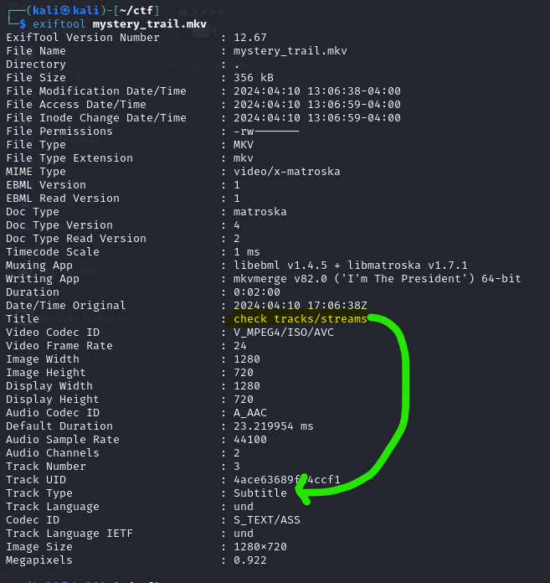

There you’ll find the title ‘check streams/tracks’. Under tracks you will see a subtitle file attached to video. Below that you will find the extension name which is Advanced SubStation Alpha.

You can use FFmpeg or any online subtitle extractor to extract it.

`ffmpeg -i "mystery_trail.mkv" -map 0:s:0 subtitle.ass`

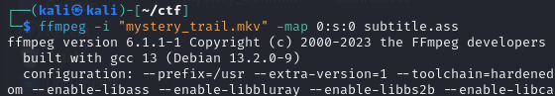

After extracting the subtitle, open it using any text editor. You will observe a few things starting from **bm90X3RoaXNfY2hlY2tfb3RoZXJfb25lfQ==** which is a false flag just to divert attention.

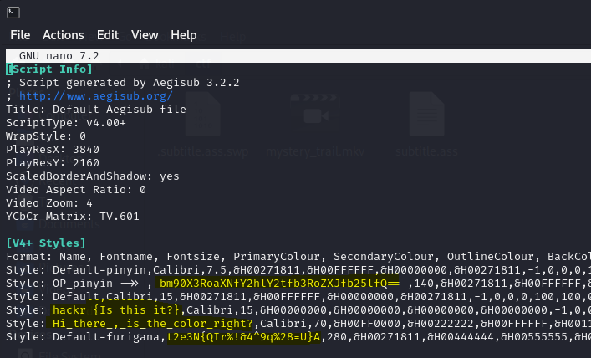

Below the false flag you observe ***hackr_{Is_this_it?}***, ***Hi_there_,_is_the_color_right?*** and ***t2e3N{QIr%!&4^9q%28=U}A.***

You can use multi base decoder like `**basecrack**` (<https://github.com/mufeedvh/basecrack>) to crack t2e3N{QIr%!&4^9q%28=U}A. Voila, you have the 2nd part of the flag:

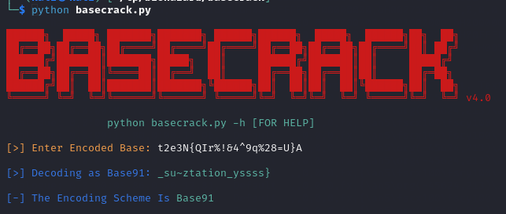

Now observe **[V4+ Styles],** there’s a format which goes like Name, Fontname, etc. One such style is “**Default**” among other styles like **hackr_{Is_this_it?}**. Below **[Events]** you see lot of lines with the “Default” in it.

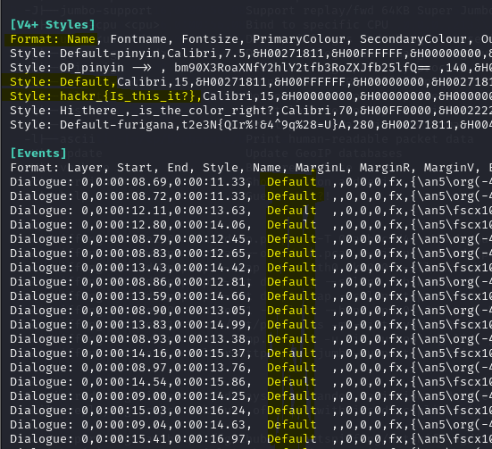

So we grep `hackr_{Is_this_it?}` and we get this:

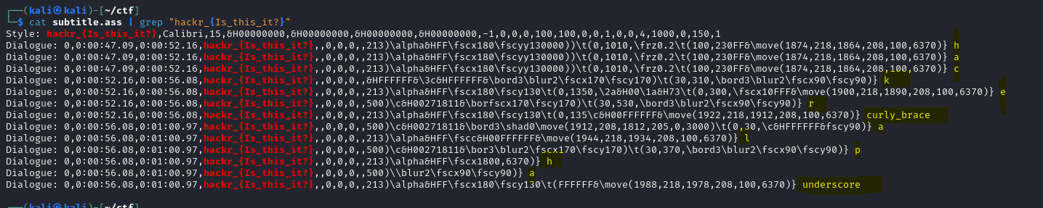

At the end of every line we see some characters. Write them in one line and you have the first part of flag: `hacker{alpha_`.

Combine the parts to get the flag: `hacker{alpha__su~ztation_yssss}`

***There’s another way to find first part of flag but it needs more inspection in the code.***



If we take ***Hi_there,_is_the_color_right?*** as a lead for solving, we see lots of hex codes. Although in this case there’s 2 extra 0’s in every hex code. Inferring the examples, if we make all the black hex codes (hex: 000000) to, let’s say, green (hex: 00FF00) we ought to see something in the video.

You will also see a ScaleX and ScaleY factor in [V4+ Styles] Format. Bump it to like 300 for more visibility.



Be sure to have the subtitle filename same as the video.

Now from 47 seconds, you will find new text coming up in video.

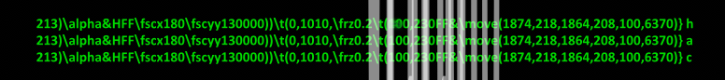

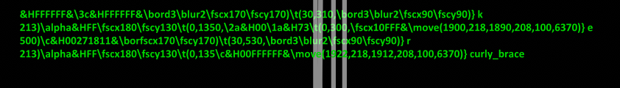

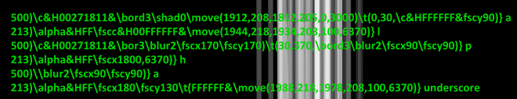

Append the last characters of each line and you will find the first part of the flag.